# xpedx.com Next generation

# *Site Admin Detail Design Document*

**Authors: Sterling Commerce**

**Date Created:** 05/18/10

**Last Updated:** 07/22/10

**File Name:** C:\Documents and Settings\bfurman\My Documents\Temp\Methodology v1.1\Project Management\TEMPLATE - DOCUMENT - Use Case Definition.docxpedx Site Admin Detail Design v1.3.doc

Approval Signatures (Mandatory)

|  |  |  |  |  |
| --- | --- | --- | --- | --- |
| **Title** | **Name** | **Signature** | **Date** | **Comments / Issues / Concerns** |
| **xpedx Owner(s)** | Steve Bugher |  |  |  |
| Cheryl Tullis |  |  |  |
| **Sterling Commerce Owner(s)** | Guy Read |  |  |  |
|  |  |  |  |

**Note**: The sign off indicates approval of all sections of the document.

Document Revision History

This chart tracks the changes introduced by the revisions to the document as the project progresses through the stages of the System Development Life Cycle (SDLC).

| Version | **Date** | **Description (Changes Made)** | **Author(s)** |
| --- | --- | --- | --- |
| 1.0 | 05/18/2010 | Initial Draft | Sterling |
| 1.1 | 05/19/2010 | Ready to deliver | Sterling |
| 1.2 | 06/28/2010 | Incorporated Feedback | Sterling |
| 1.3 | 07/22/2010 | Incorporated Feedback | Sterling |

Related or Reference Documents

| Document Name | Description | Owner | Location |
| --- | --- | --- | --- |
| SCI_Xpedx Solution Definition Document v1.5 | Solution Definition document | Sterling Commerce |  |
|  |  |  |  |

TABLE OF CONTENTS

1. Introduction 4

1.1 Document Purpose 4

1.2 Document Audience 4

2 Site Admin 5

2.1 Functions & Solution 5

2.2 Master System 7

2.3 Implementation Details 7

2.3.1 Entity objects. 7

2.3.2 Actions involved and Functions 7

2.3.3 API Details 7

2.4 Process Flow 7

2.5 Screen Shot 8

2.6 Open Questions 12

2.7 Assumptions 12

3 Glossary of Terms 12

# Introduction

## Document Purpose

This document is the governing functional design document for Site Admin functionality. It presents significant decisions and constructs used in developing the functionality. Testing, builds, configuration management are not covered in this document.

The document will also serve the purpose of keeping a list of assumptions that were made during design discussions.

## Document Audience

This document is intended for management and technical staff working on this project, xpedx IT and Business, webMethods, Legacy(MAX and ACCESS), HP, IW, xpedx/IP Network Team. Sterling will use the document during design and configuration for design consideration.

# Site Admin

## Functions & Solution

This depicts the roles and definition of the various site administrators for the xpedx solution. On a high level these are the following groups that are required:

* Division Admin - They will be assigned the Division Admin Group.
* Security Admin - They will be assigned the Security Admin Group
* eBusiness Admin – They will be assigned the eBusiness Admin Group.
* CSR – Customer Service Reps.
* Promotion Admin - They will be assigned the Promotion Admin Group.
* Catalog Admin - They will be assigned the Promotion Admin Group.
* Manage My Items Admin - They will be assigned the Manage My Items Group.
* Support Desk Admin
* Integration Admin - Will be able to manage integration related fields in Customer & User profile.

These users are created as internal users and belong to the xpedx storefront. In the process of creating these users, they will be assigned to user groups. Each user group will have permission to certain resources or tasks. Based on the permission the user will see or do certain activities.

User groups are a collection of users who perform a similar task. For example, a group of customer service representatives might be put in a Customer Service Representative User group. Users can belong to multiple user groups to which permissions are assigned. A user who belongs to multiple user groups retains the least restrictive set of permissions defined by the groups they belong to. For example, if a user belongs to a pricing administrator user group and they also belong to the item administrator, the user then has access to both functions. Please see the screen in the screen shots section for the concept of configuring the user groups and also internal user creations through COM screens.

Note - “Security Driven” in Header (table below) indicates that the function is secured at the Division Level, otherwise user can be / manage all.

|  |  |  |  |  |  |  |  |  |  |  |  |  |
| --- | --- | --- | --- | --- | --- | --- | --- | --- | --- | --- | --- | --- |
| Admin Type | Manage External Customers & Users  (Security Driven) | Manage Internal Users | Manage/Create Order  (Security Driven) | Manage Division Profile | Manage Promotions & Coupons through SBC | Manage Entitlements through SBC | View Invoices | Manage News | Reset Passwords  (Security Driven) | Catalog - Narrow By | Manage My Items | Integration Related Fields on User/ Customer Profile |
| Division Admin – Call Center | Read/  Update | NA | Read / Update | NA | NA | NA | NA | Read/  Update | Reset | NA | NA | NA |
| eBusiness Admin – Call Center and SBC | Read/Update | NA | Read/Update | NA | NA | Read / Update | NA | Read / Update | Reset | NA | NA | NA |
| Security Admin – Call Center | NA | Read/Update | NA | NA | NA | NA | NA | NA | Reset | NA | NA | NA |
| CSR – Call Center | Read/  Update | NA | Read/  Update | NA | NA | NA | NA | NA | Reset | NA | NA | NA |
| Promotion Admin - SBC | NA | NA | NA | NA | Read / Update | NA | NA | NA | NA | NA | NA | NA |
| Catalog Admin Group - SBC | NA | NA | NA | NA | NA | Read/Update | NA | NA | NA | Read/Update | NA | NA |
| Manage My Items Admin – Call Center | NA | NA | NA | NA | NA | NA | NA | NA | NA | NA | Read/Update | NA |
| Support Desk – Call Center and SBC | Read/Update | N/A | Read/Update | Read/Update | NA | Read / Update | NA | Read / Update | Reset | NA | NA | NA |
| Integration Admin – Call Center | Read | NA | NA | NA | NA | NA | NA | NA | NA | NA | NA | Read / Update |
| View Invoices | NA | NA | NA | NA | NA | NA | Read | NA | NA | NA | NA | NA |

## Master System

Sterling is the master of system for these admin users. However, these admin can be internal users and will be managed in the Active Directory. The details of the Active directory approach are mentioned in the Security DDD.

## Implementation Details

## Entity objects.

* NA

## Actions involved and Functions

* NA

## API Details

* NA

## Process Flow

Not Applicable

## Screen Shot

The screen shots pasted here are from Sterling OOTB solution. These screens are OOTB representation of the concept and do not indicate the roles as per xpedx requirements.

***Modify User (Internal Users)***

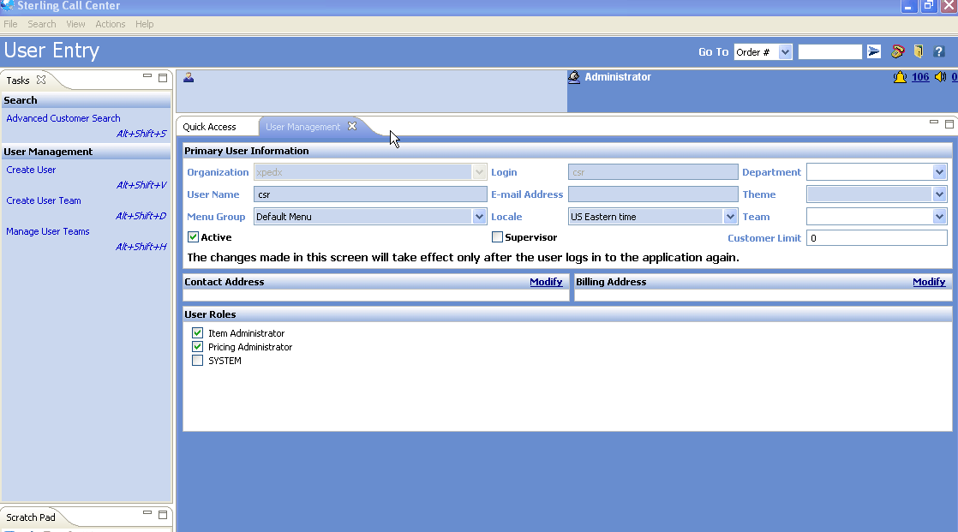

***New User Creation (Internal Users)***

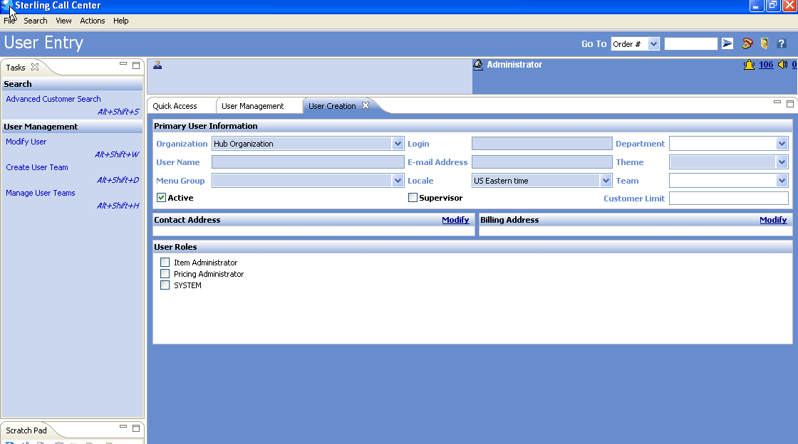

***User Groups (List)***

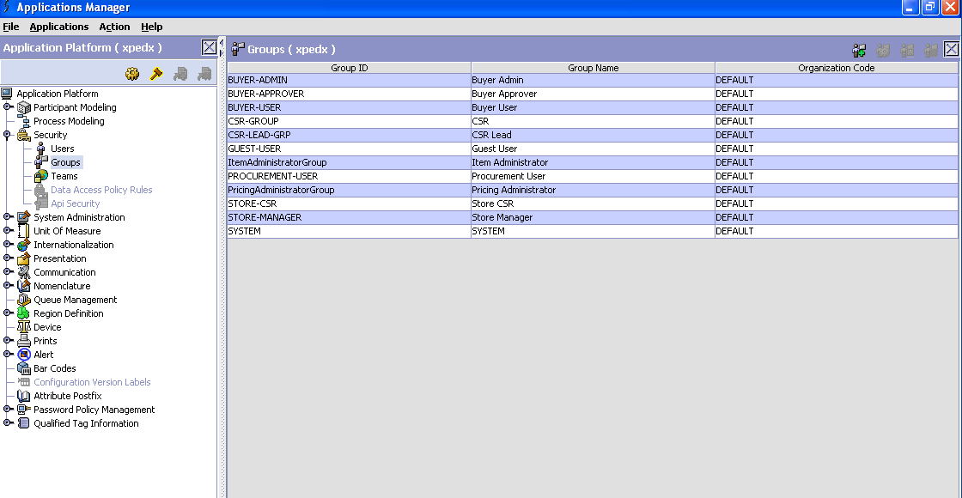

***User Group Assignment Screen***

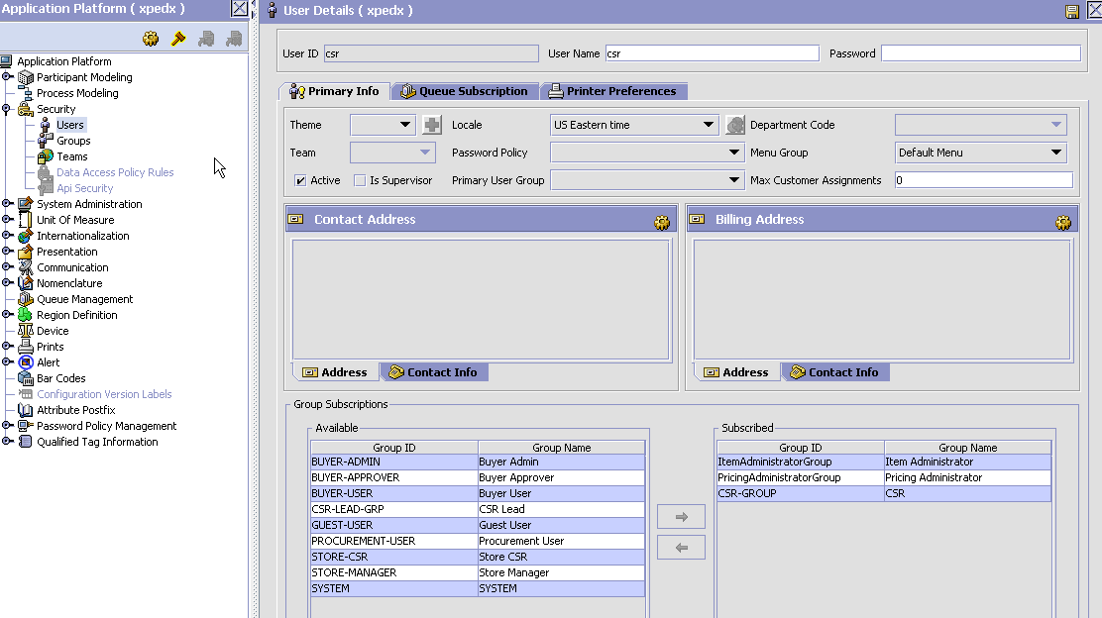

***Group to Resource assignment***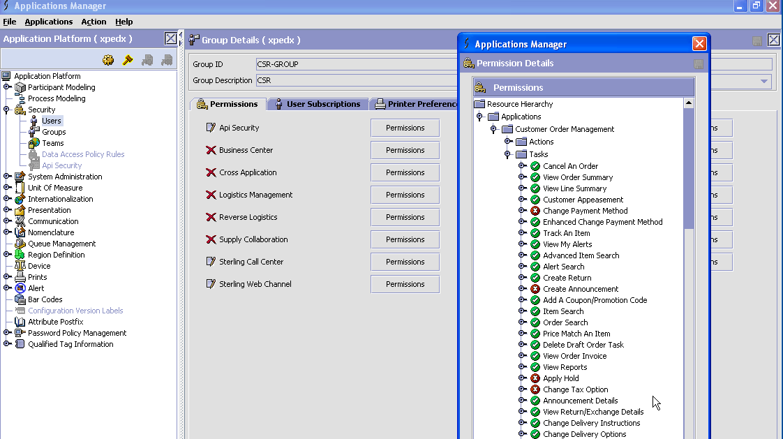

## Open Questions

NA

## Assumptions

1. Division one time load will be available before Go live to Sterling, xpedx is still working on the time lines if ongoing loads will be sent on a daily basis.

# Glossary of Terms

|  |  |  |
| --- | --- | --- |
| S. No. | Term | Definition |
| 1. | Entity Object | Database and Java entity objects to store the required data. |
| 2. | Action Class | Struts controllers which redirects the parameters and does some business logic before calling the business APIs. |
| 3. | BR1 | Business Release 1 |
| 4. | SBC | Sterling Business Center |
| 5. | CC | Call Center |